Weekend Activities at An Riocht: 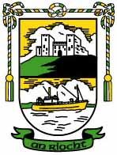
Fridays 630pm P5 & P6 Gaelic
Saturdays 11am P1 & P2 Gaelic
Saturdays 12pm P3 & P4 Gaelic
Saturdays 1pm to 1.45pm U8 Camogie
Saturdays 1.45pm to 1.45pm U10 & U12 Camogie
ALL of the above to be outdoor ( weather permitting)

Mondays 630pm U12( Born 03/04) Indoor Gaelic
ALSO
Friday night is Cinema & Pizza night up at ‘The Kingdom’ at 7.30pm
Dates for Your Diary:
Date | Activity
Mon 20th April | Meeting of the Parent Group and P3 parents re:  Holy Communion
Fri 24th April | School Photographer in School
Mon 27 April | P3/4 Assembly
Mon 27 April – 1st May | Newry Feis
Wed 29th April | Admission letters posted out to incoming P1 pupils
Sat 2nd May | Sacrament of Holy Communion celebrated at 10.00am
Mon 4th May | Bank Holiday – School Closed
Sun 10th May | P7 Parish Ceremony at 9.00am mass
Mon 18th May | Sacrament of Confirmation at 4.00pm;  School closes at 12.30pm
Tuesday 19th May | P2/3 class assembly at 10.00am
Sat 23rd May | P7 notification of post-primary school placement
Friday 29th May | Provisional date for Sports Day

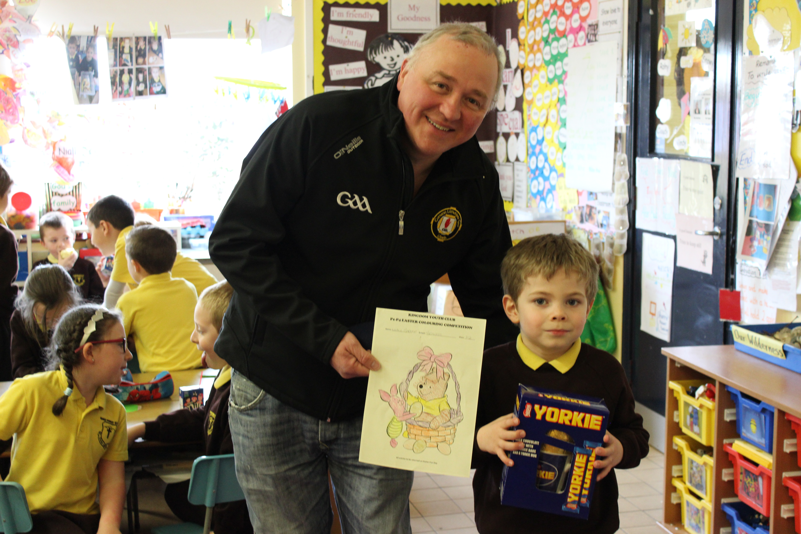
Well done Niall. Thanks Turlough

SCHOOL CLOSINGS 2004/05

The following are the school closings for the school year 2004/05.
BBr
Autumn Mid-term Thursday 30 October 2004
Friday 31 October 2004
Monday 01 November 2004

Immaculate Conception Wednesday 08 December 2004
Christmas Vacation School clos M20 December 2004
School re-opens Friday 07 January 2005

Spring Mid-term Monday 14 February 2005

St Patrick’s Holiday Thursday 17 March 2005

Easter Vacation School closes Thursday 24 March 2005
School re-opens Monday 04 April 2005

Mayday Monday 02 May 2005

Spring Holiday Friday 27 May 2005
Monday 30 May 2005

Summer Vacation Sc closes Thursday 30 June 2005

These are the closings as we know them at this time.

Notification of any alterations will be given at the appropriate tim

We trust you will find this information useful.


Grange Newsletter
Vol 12Issue26
17 Apr 2015

Guess Who?
On a recent trip to The Silent Valley, some staff members were more enthusiastic that others in getting to the top of Ben Crom first.
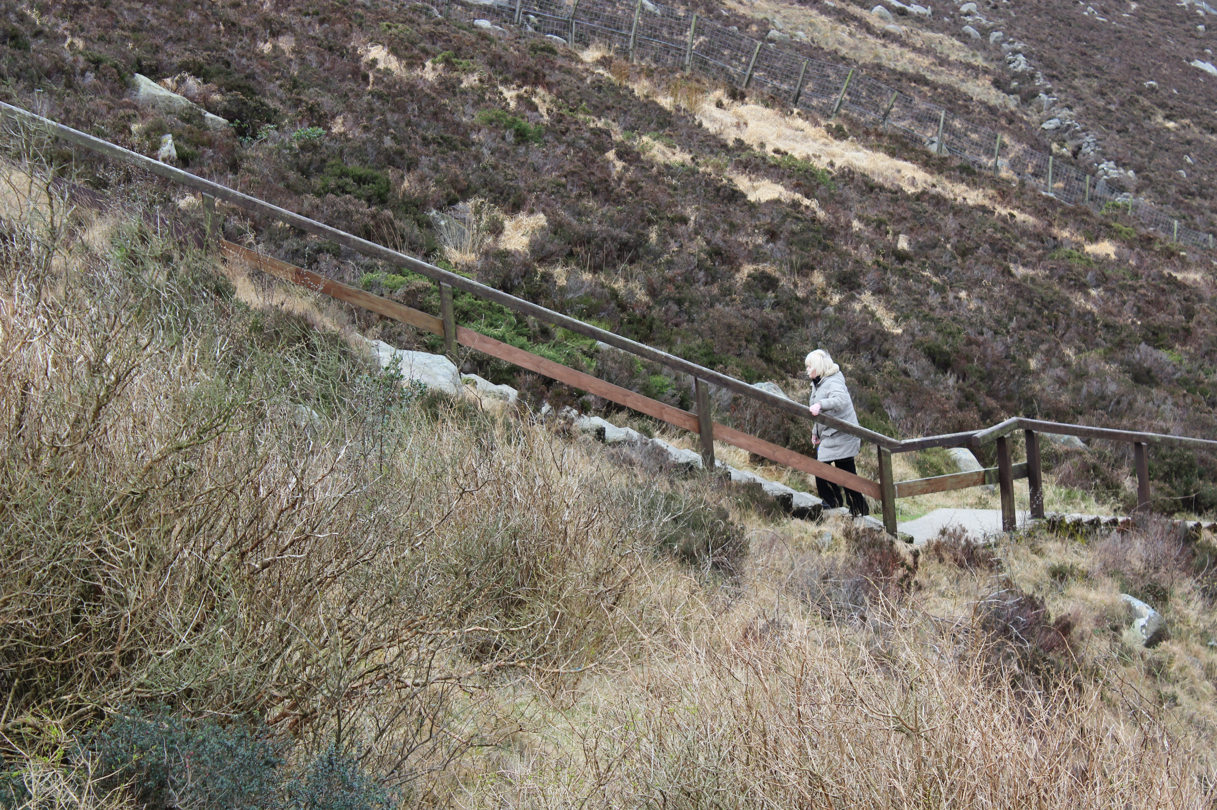
Article 29:
Education must develop every child’s personality, talents and abilities to the full. It must encourage their respect for human rights, as well as respect for their parents, other cultures and
the environment.

Primary 5/6 Class Assembly:
Well done to the pupils from the P5/6 class who presented our monthly class assembly at the beginning of Holy Week. Next assembly involves our P3/4 class on Monday 27th April at 10.00am. All are welcome.
LENT:
Following another marvellous Lenten Trocaire campaign during 2015, the grand total raised by our school was: £734.67. |This total was raised through our weekly class raffles, the Bring & Buy Sale, families sending in their own Trocaire boxes and individual pupils being creative themselves.
We will shortly have a visit from Rosie, our Trocaire representative, in order to make the presentation. A BIG Well Done to all the efforts of all involved, pupils parents and staff.
Our School in the Parish:
This weekend the family of Sean Small will participate at the Offertory of Sunday’s mass and we conclude on 26th April with the family of Shannon Trainor. On behalf of the school and parish, we thank all children and their families for their engagement.
Holy Communion:
All families will today receive a letter asking for assistance donating items for the Holy Communion party. We ask that families return the slips on/before Friday 24th April to allow the organising committee time to put things in place. Donated items can be left in to school at any time beforehand. If trays/tins are being sent in, please stick a label with your name on it. Your assistance is much appreciated.

Request to Primary 3 parents:
Before Easter, the parents of children in the Primary 3 class were surveyed to ascertain if they could assist with our Holy Communion celebrations on Friday 1st /Saturday 2nd May. We still await a response from a number of families. Help available on Saturday morning is vital in order to provide our customary Holy Communion party for the children. Please let us know on Monday coming of your availability as the organising meeting is on Monday evening as noted below.
Friends of Grange / Primary 3 parents Meeting re: Holy Communion:
There will be a meeting for all members of the Parent Group and Primary 3 parents at 7.00pm on Monday 20th April to finalise arrangements for Holy Communion and fundraising plans for Term 3. We ask that everyone makes themselves available on the night.
Tempest Photography:
This school photography company will visit school on Friday 24th April. We plan to complete a large number of photograph sets on this day, to include: individual, family, current P1, P2 & P7 class year groups. There were no photographs taken last year due to a lack of demand.
We anticipate that any family sets, where parents wish to bring in pre-school /post-primary members for their inclusion will take place from 8.15-9.00am on the day. A note was sent home today to ascertain prospective numbers.

Sentinus Construction Challenge:
Well done to Amy, Hattie, Ronan and Gerry-Lee who were chosen by their peers to represent our school at a K-Nex Construction Challenge in St. Colman’s College on Thursday.
House Point Winners:
Well done to our Term 2 house point competition winners : KNOCKCHREE
Their reward will be a trip to The Kingdom Movie House on Tuesday.
Competition Winner:
Well done to Niall Barker (P2), who received a belated Easter Egg on Monday from Turlough Eastwood following his success in an Easter colouring competition at The Kingdom.
Football next Friday:
We have been invited to enter 2 x 7-a-side mixed teams for a tournament in An Riocht next Friday. We will confirm attendees next week.
School Uniform Orders for 2015-16:
Today is the final date for orders to be placed for uniform requirements for next year. Murphy’s clothing outlet in Kilkeel has asked once again if parents could drop in. This allows for a group bulk order and preferable group discount for orders placed. Individual orders placed after this date might incur increased costs.
Coffee Morning for the Hospice - Camino de Santiago Challenge:
Sheila Mc Alinden continues her preparations for walking a leg (115km in 6 days) of the famous Camino pilgrimage walk in May. To help with her fundraising efforts, she plans to host a Coffee Morning this coming Saturday 18th April (10.30am-2.00pm). Sheila is looking for our support in whatever way we can by attending, donating home baking, making donations and letting others know about the event. Sheila can be contacted on :07753406882. Please lend Shelia your support in any way possible. Any donations sent in to school will be forwarded.
After School Clubs / Football at the Kingdom:
A timetable for Afterschool Clubs in Term 3 will be organised shortly. The football at An Riocht will be for any P3/4 children who wish to participate.
There will be NO football next week.
Lights, Camera, Confidence Drama Club:
Further to the many replies returned, we are delighted to announce that we will be running with the 2 sessions of this Afterschool club provided by the above company. A letter explaining the details was sent home today with 69 pupils.
.
Newry Feis:
This week pupils registered for Newry Feis received their Registration Card with their date, time and venue (P1-4 take note)
Grange Primary School Website:
www.grangeprimaryschoolkilkeel.co.uk

