Dates for Your Diary:
Date | Activity
Sun 10th May | P7 Parish Ceremony at 9.00am mass
Mon 18th May | Sacrament of Confirmation at 4.00pm;  School closes at 12.30pm
Tuesday 19th May | P2/3 class assembly at 10.00am
Thursday 21st May | May Procession in honour of Our Lady at 1.00pm
Sat 23rd May | P7 notification of post-primary school placement
Mon 25th-Thurs 29th May | School Closed to Pupils
Thursday 28th May | Induction Day for St. Louis Year 8s in September
Friday 29th May | Provisional date for Sports Day
Tuesday 2nd June | Kilbroney Primary Schools’ Cross-country event
Friday 5th June | St. Mark’s High School Induction Day – Year 8s
Tuesday 9th June | Grange Primary School Musical Evening 7.30pm
Thursday 11th June | Prospective Primary 1 Induction Day – 2.00pm
Monday 15th June | Environmental Beach Clean – Greencastle – 10.00am
Thursday 18th June | Kilkeel Primary School Asthma Sports event -10.00am
Friday 19th June | St.Columban’s High School Induction Day – Year 8s
Tuesday 23rd June | End of Year Leavers’ Mass and Presentation – 10.00am
Wednesday 24th June | Primary 1-4 Trip to Castlewellan
Thursday 25th June | Primary 4-7 trip to Lisburn
Tuesday 30th June | School closes for summer at 12.00noon

DRAMA Dates: GRANGE PRIMARY SCHOOL, KILKEEL
Please find below the dates of the Drama Club:
WEEK | DATE
3 | 11TH May
 | 18th May - CONFIRMATION
 | 25TH May -OFF
4 | 1st June
5 | 8th June
6 | 15th June
7 | 22nd June - unconfirmed
CASH FOR CLOBBER:

WE ARE ATTEMPTING TO ADD TO OUR TOTAL OF BAGS COLLECTED IN TERM 1 & 2 OVER THE NEXT WEEK.

PLEASE GET YOUR BAGS IN AS SOON AS POSSIBLE.

Grange Primary School Website:
www.grangeprimaryschoolkilkeel.co.uk

SCHOOL CLOSINGS 2004/05

The following are the school closings for the school year 2004/05.
BBr
Autumn Mid-term Thursday 30 October 2004
Friday 31 October 2004
Monday 01 November 2004

Immaculate Conception Wednesday 08 December 2004
Christmas Vacation School clos M20 December 2004
School re-opens Friday 07 January 2005

Spring Mid-term Monday 14 February 2005

St Patrick’s Holiday Thursday 17 March 2005

Easter Vacation School closes Thursday 24 March 2005
School re-opens Monday 04 April 2005

Mayday Monday 02 May 2005

Spring Holiday Friday 27 May 2005
Monday 30 May 2005

Summer Vacation Sc closes Thursday 30 June 2005

These are the closings as we know them at this time.

Notification of any alterations will be given at the appropriate tim

We trust you will find this information useful.


Grange Newsletter
Vol 12Issue29
08 May 2015

Well done to our First Holy Communicants on receiving the Sacrament of the Blessed Eucharist last Saturday
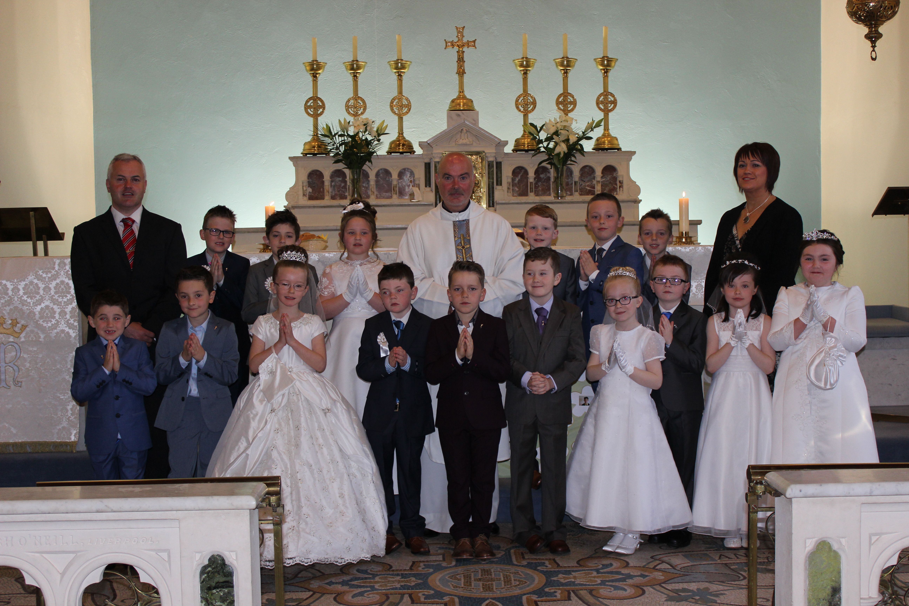
Article 24:
Each child has the right to the best possible health, good quality health care, clean water and nutritious food.

Holy Communion:
We had another special day last Saturday when the Primary 4 children celebrated their First Holy Communion. Sincere thanks must go to all those who helped with contributions for the party and special thanks to the parents who set up on Friday and those who assisted on the Saturday morning. Sincere thanks to the members of the Friends of Grange Parent group.It would not be possible without your help.
Primary 7 Parish Ceremony:
The Primary 7 pupils, preparing to receive the Sacrament of Confirmation on 18th May will have their pre- Confirmation Parish Ceremony at the 9.00am mass in Grange on Sunday 10th May.
Confirmation:
We celebrate the Sacrament of Confirmation in the parish on Monday 18th May at 4.00pm in Massforth. On this day, school will close for all pupils at 12.30pm, following lunch. This gives all those involved in the ceremony some time to prepare.
All choir members have been invited to assist with the ceremony also. We want to ensure our school is well represented in this regard as choir members from all 3 schools will be present on the day.
Parent Governor:
Today saw the close of nominations to take up the role of parent representative to the present Board of Governors. On Monday, parents will receive a Ballot Paper detailing the names of all nominees. Both parents are entitled to vote. Please place a single tick in the box beside the name of the parent you wish to elect and return to school in the envelope marked ‘Clerk of Elections’. Close for receipt of votes is Friday 22nd May. Further to this date, the clerk, Mr. Sean Rogers will contact nominees to arrange a date for the counting of votes. If any parent has any questions to ask , please contact the Principal, Mr. Mc Kinley.
Klbroney Cross Country:
This year’s event takes place on Tuesday 2nd June at 10.00am in Kilbroney Park. The event is open to boys and girls from Primary 4-7. Children wishing to attend will need to show their ability to complete the distance and also be able to be brought to and from the event on the day.
Sports Day 2015:
Our annual ‘Alternative Sports Day’ is scheduled to take place on Friday 29th May, up at An Riocht, from 10.00am. As previously, all the children will be split into TEAMS with this year’s theme being The Irish Open, coinciding with it being held at The Royal County Down at the same time. A correspondence went out today to confirm pupils attending and volunteers willing to help out. We all hope to have our willing ‘Volunteer Team Leaders’ to help us again this year.
ECO- Schools Beach Clean:
This Term, we have a Sponsored Environmental Beach Clean scheduled to take place on Monday 15th June. Next week, each child will receive an explantory letter and Sponsor Form to assist with the activity.Similar to last year, we are hoping as many of our adult ‘volunteers’ will be able to assist us on the day. Many thanks to all those who have already raised some funds for this event.
End of Year Trips:
All children should have received notification of the details of their end of year trip.
Tempest Photography:
All individual and family group proof photos went out on Tuesday. We ask that all orders / payments are sent in to school as detailed and enclosed in the accompanying envelope on/before Friday 22nd May. We need to stick to this order schedule to allow for all orders to be processed in early June.
Primary 2/3 Assembly:
The next assembly, presented by the P2/3 class will take place on Tuesday 19th May at 10.00am. Monday 4th June. Parents and family members are warmly invited to attend.
After School Clubs / Football at the Kingdom:
We only had 6 participants for this week’s P3/4 football coaching with Turlough at An Riocht. Next Wednesday, 13th June we are opening it up to any P3, 4 and 5 pupils to attend. Children are asked to ensure they bring appropriate clothing for outdoor activity. If it is too wet/cold, sessions will be held in the hall. Children are to be picked up at 4.00pm sharp.
Cumann na mBunscol:
Weather permitting, today we should have attended a Qualifying Football Blitz for all 7 -a - side schools in Down. The competition will identify schools who will qualify for the knockout stages of the Primary School football league.
Grand Opera House Panto-2016:
Our present P3-6 pupils were recently given a note asking them to confirm their desire to attend next year’s Pantomime in The Grand Opera House in January 2016. Similar to this year, we anticipate the cost to be around £15 per pupil. We will look for a £10 deposit in early September with the reaminder to be paid by the end of November. The 2015-16 panto is Snow White. Please return replies in order to allow us to purchase tickets for all those looking to attend.
ASSESSMENT:
During the month of May, each class will be involved in various forms of assessment, to help in producing both diagnostic and summative data on each pupil’s academic performance in the key curriculum areas of Literacy & Numeracy. In helping assist with the administration, consistency of whole school approach and test reliability, assessments involving children from Primary 3 upwards take place in the Assembly Hall. This can be a daunting experience for any child and despite our best efforts to reassure children, some children can become nervous at the prospect and allow the whole thing to put them off. Others think it’s great. We therefore ask that each parent has a chat with their child in relation to simply listening to their teacher’s instructions and trying their best. All details/ instructions will be gone over a number of times in each class before the children proceed to the hall.
Lights, Camera, Confidence Drama Club:
Week 3 of the Drama Club will take place on Monday 11th May.
Cycling Proficiency:
Pupils contnue to participate in this scheme as per timetable.

