SCHOOL CLOSURES 2015-16

The following are the school closings for our pupils for the year:

Staff Development Days Monday 26 October 2015 Tuesday 27 October 2015
Autumn Mid-term Wednesday 28 October 2015
Thursday 29 October 2015
Friday 30 October 2015

Christmas Vacation School closes Friday 18 December 2015 @ 12.30pm
School reopens for all pupils on Tuesday 05 January

Spring Mid-term holiday Monday 15 February 2016
Tuesday 16 February 2016
Wednesday 17 February 2016
Thursday 18 February 2016
Staff Development Day Friday 19 February 2016

St Patrick’s Holiday Thursday 17 March 2016
Friday 18 March 2016

Easter Vacation School closes Thursday 24 March @ 12 noon.
School reopens for all pupils on Monday 04 April

May Bank Holiday Monday 02 May 2016
May Bank Holiday Monday 30 May 2016

Staff Development Days Tuesday 31 May 2016
Wednesday 01 June 2016
Thursday 02 June 2016
Provisional Sports Day Friday 03 June 2016

School closes for the Summer Break on Thursday 30 June 2015 @ 12noon.

School Staff Development Days are days scheduled throughout the course of the school year. On these days, pupils do not attend. These days, however, can be subject to change due to unforeseen circumstances throughout the year.

Please refer to our School Calendar on our school website for dates of other specific events in advance.

SCHOOL CLOSINGS 2004/05

The following are the school closings for the school year 2004/05.
BBr
Autumn Mid-term Thursday 30 October 2004
Friday 31 October 2004
Monday 01 November 2004

Immaculate Conception Wednesday 08 December 2004
Christmas Vacation School clos M20 December 2004
School re-opens Friday 07 January 2005

Spring Mid-term Monday 14 February 2005

St Patrick’s Holiday Thursday 17 March 2005

Easter Vacation School closes Thursday 24 March 2005
School re-opens Monday 04 April 2005

Mayday Monday 02 May 2005

Spring Holiday Friday 27 May 2005
Monday 30 May 2005

Summer Vacation Sc closes Thursday 30 June 2005

These are the closings as we know them at this time.

Notification of any alterations will be given at the appropriate tim

We trust you will find this information useful.


Grange Newsletter
Vol 13 Issue 1
04 Sep 2015

We welcome our 2015-16
Primary One class.
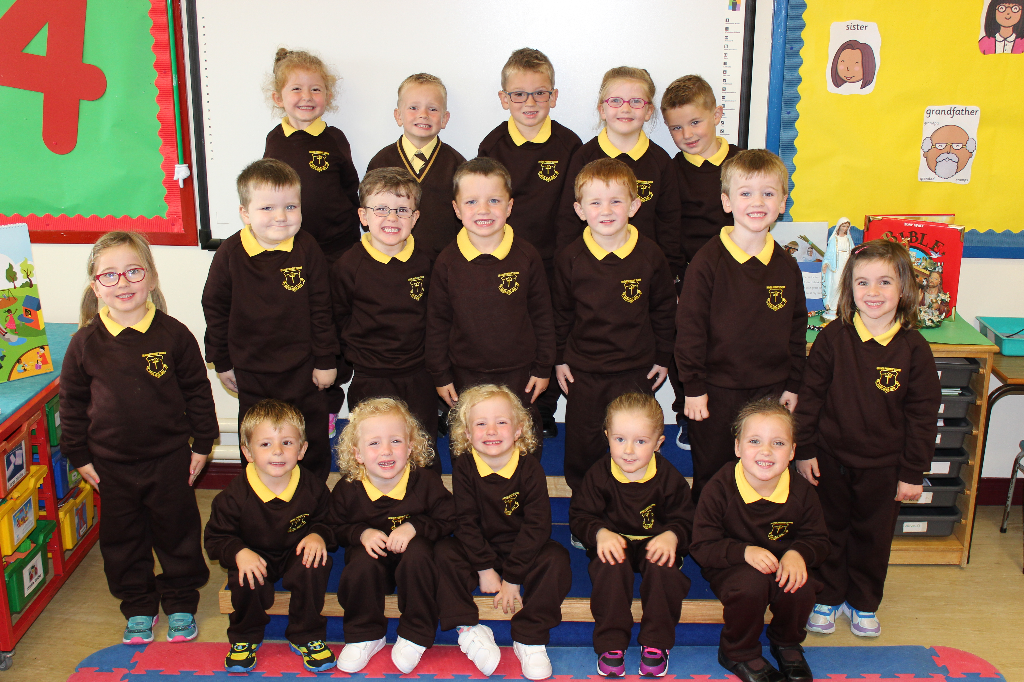

Back row: Aoife, Nathan, Dylan, Siofra, Shawn;
Middle row: Aoife , Joseph , Ryan, Brian , Darren , Ryan, Leanne;
Front row: Darragh , Alesha , Brianne, Kirya, Clarice.

School tel: 4176 2033 email: info@grange.kilkeel.ni.sch.uk
Please access our website at:www.grangeprimaryschoolkilkeel.co.uk

Welcome to the first issue of our school newsletter for the new school year. We welcome back all our pupils and staff and pray for a happy and fulfilling year at school.
Primary 1 Milestone:
We welcome all our pupils and parents back to school and we especially welcome our new Primary 1 intake. We wish them many happy and informative years in Grange Primary School. Look out in this week’s local press for their photo.
Back to school:
This is a very busy time for pupils, teachers and parents. At the start of the new school year many notes and forms are sent home. On Wednesday, parents should have received a number of Data Collection Forms including: a consent form detailing the names of all adults permitted to collect a child from school; a form asking for parental consent to allow child(ren) to be photographed in a school setting for various medium; ICT Parent Permission and Pupil Consent forms; and a general ‘Out of School’ permission form.
We emphasise to parents the importance of completing and returning these forms as soon as possible providing school with up to date mobile contact numbers so as to enable us to make contact in case of emergency.
Child Protection:
In our whole school review of issues relating to Child Protection and school procedures, we draw parents’ attention to the procedure for removing a child during the course of a normal school day. If a parent knows in advance of an occasion when a child will be collected early from school, they should inform school in advance either in writing or through the secretary. When the child is to be collected, parents should report to the office (9.30am – 1.00pm) where Mrs Murnion will make arrangements. Thereafter, (1.00 – 2.45pm) parents should gain entrance through the front door and make contact with either the Principal / Vice-Principal. On the occasion of a child being removed early from school, parents must sign a Register in the office.
Parents are advised that under no circumstances should they proceed directly to a child’s classroom without first making contact through the office.
Money Matters:
The cost of school dinners is now £2.50 per day/ £12.50 per week. Unfortunately, our survey in June in relation to school meal options only yielded a 22% response and left us with no option but to continue with the traditional 2 course meal. We ask that, as far as possible, money for dinners each week is brought in to school on Monday or Tuesday to assist with banking arrangements.
Altar Servers:
A new rota for altar servers will commence shortly. A letter was sent home again this week to all P5-7 pupils asking for them to consider becoming a server to assist at masses in Grange.
Beginning Year Mass:
Our first school mass will be in Grange chapel on Monday 14 September at 9.30am, where pupils will participate in the Liturgy.
Swimming lessons:
Pupils from P5& 6 are due to commence their swimming lessons for Term 1 on Thursday 10 September. A letter and permission form was sent home this week. To all P5-7 pupils. Please return permission forms prior to commencement date.
Friends of Grange Meeting:
There will be a meeting for any parents able to come along on Monday night coming, 7th September, at 7.00pm. The main item will be the upcoming
Jim Devine concert.
Come Dancing – Learn to Jive:
In the lead up to our BIG Jim Devine event in The Carrickdale Hotel on Friday 02 October, we have a series of jiving lessons taking place in Grange school hall, commencing this Monday, 7th September, from 8.00-10.00pm for 4 weeks (Cost £8.00 per lesson). There has been a lot of anticipation for this activity. We encourage everyone to come along, get involved and get dancing. This will be a ‘Strictly’ fun and fit venture.
Musical Tuition:
All pupils in P4-7 were given a letter outlining the opportunity to avail of tin whistle lessons again this year with Mr. Danny Mc Greevy. This is an important service especially due to the discontinuation of the Musical Pathways Project.
Milk:
Any children wishing to take milk in Term 1 should return the Reply Slip sent home.
Pupil Health and Safety:
We remind all parents that we have a child in school with a diagnosed NUT ALLERGY. Please ensure no nuts or products containing nuts are sent to school as part of lunch items.
Flu Vaccination Programme:
We have been notified that all primary school pupils will be offered the ‘flu vaccine’ as part of the annual school’s Health Immunisation Programme. This will occur in our school on is Wednesday 25th November. Consent forms to follow.
Pantomime:
Yesterday, P4-7 parents received a letter informing them of the details/cost for our school’s attendance at ‘The Pantomime’ in January. We need to have exact numbers confirmed by Monday coming in order to finalise our bookings. Details of the P1-3 panto outing will be provided shortly.
GL Assessment Tranfer Test:
Any P7 parents wishing their child to sit the Post-Primary Consortium Entrance Test must register their child with the Registration Centre (Sacred Heart Grammar School) on/before 2.00pm on Friday 25th September.
Dates for the Diary:
Monday 14 September – Beginning School Year Mass at 9.30am;
Monday 28 September – Primary 6/7 class assembly;
Friday 25 September – Registration deadline for 2015 GL Assessment Transfer Test;
Friday 25 September – European Day of Languages;
Monday 28 September – Primary 1 pupils remain until 2.00pm
Monday 05 October – Deposit deadline for P4-7 pantomime;

Welcome to the first issue of our school newsletter for the new school year. We welcome back all our pupils and staff and pray for a happy and fulfilling year at school.
Primary 1 Milestone:
We welcome all our pupils and parents back to school and we especially welcome our new Primary 1 intake. We wish them many happy and informative years in Grange Primary School. Look out in this week’s local press for their photo.
Back to school:
This is a very busy time for pupils, teachers and parents. At the start of the new school year many notes and forms are sent home. On Wednesday, parents should have received a number of Data Collection Forms including: a consent form detailing the names of all adults permitted to collect a child from school; a form asking for parental consent to allow child(ren) to be photographed in a school setting for various medium; ICT Parent Permission and Pupil Consent forms; and a general ‘Out of School’ permission form.
We emphasise to parents the importance of completing and returning these forms as soon as possible providing school with up to date mobile contact numbers so as to enable us to make contact in case of emergency.
Child Protection:
In our whole school review of issues relating to Child Protection and school procedures, we draw parents’ attention to the procedure for removing a child during the course of a normal school day. If a parent knows in advance of an occasion when a child will be collected early from school, they should inform school in advance either in writing or through the secretary. When the child is to be collected, parents should report to the office (9.30am – 1.00pm) where Mrs Murnion will make arrangements. Thereafter, (1.00 – 2.45pm) parents should gain entrance through the front door and make contact with either the Principal / Vice-Principal. On the occasion of a child being removed early from school, parents must sign a Register in the office.
Parents are advised that under no circumstances should they proceed directly to a child’s classroom without first making contact through the office.
Money Matters:
The cost of school dinners is now £2.50 per day/ £12.50 per week. Unfortunately, our survey in June in relation to school meal options only yielded a 22% response and left us with no option but to continue with the traditional 2 course meal. We ask that, as far as possible, money for dinners each week is brought in to school on Monday or Tuesday to assist with banking arrangements.
Altar Servers:
A new rota for altar servers will commence shortly. A letter was sent home again this week to all P5-7 pupils asking for them to consider becoming a server to assist at masses in Grange.
Beginning Year Mass:
Our first school mass will be in Grange chapel on Monday 14 September at 9.30am, where pupils will participate in the Liturgy.
Swimming lessons:
Pupils from P5& 6 are due to commence their swimming lessons for Term 1 on Thursday 10 September. A letter and permission form was sent home this week. To all P5-7 pupils. Please return permission forms prior to commencement date.
Friends of Grange Meeting:
There will be a meeting for any parents able to come along on Monday night coming, 7th September, at 7.00pm. The main item will be the upcoming
Jim Devine concert.
Come Dancing – Learn to Jive:
In the lead up to our BIG Jim Devine event in The Carrickdale Hotel on Friday 02 October, we have a series of jiving lessons taking place in Grange school hall, commencing this Monday, 7th September, from 8.00-10.00pm for 4 weeks (Cost £8.00 per lesson). There has been a lot of anticipation for this activity. We encourage everyone to come along, get involved and get dancing. This will be a ‘Strictly’ fun and fit venture.
Musical Tuition:
All pupils in P4-7 were given a letter outlining the opportunity to avail of tin whistle lessons again this year with Mr. Danny Mc Greevy. This is an important service especially due to the discontinuation of the Musical Pathways Project.
Milk:
Any children wishing to take milk in Term 1 should return the Reply Slip sent home.
Pupil Health and Safety:
We remind all parents that we have a child in school with a diagnosed NUT ALLERGY. Please ensure no nuts or products containing nuts are sent to school as part of lunch items.
Flu Vaccination Programme:
We have been notified that all primary school pupils will be offered the ‘flu vaccine’ as part of the annual school’s Health Immunisation Programme. This will occur in our school on is Wednesday 25th November. Consent forms to follow.
Pantomime:
Yesterday, P4-7 parents received a letter informing them of the details/cost for our school’s attendance at ‘The Pantomime’ in January. We need to have exact numbers confirmed by Monday coming in order to finalise our bookings. Details of the P1-3 panto outing will be provided shortly.
GL Assessment Tranfer Test:
Any P7 parents wishing their child to sit the Post-Primary Consortium Entrance Test must register their child with the Registration Centre (Sacred Heart Grammar School) on/before 2.00pm on Friday 25th September.
Dates for the Diary:
Monday 14 September – Beginning School Year Mass at 9.30am;
Monday 28 September – Primary 6/7 class assembly;
Friday 25 September – Registration deadline for 2015 GL Assessment Transfer Test;
Friday 25 September – European Day of Languages;
Monday 28 September – Primary 1 pupils remain until 2.00pm
Monday 05 October – Deposit deadline for P4-7 pantomime;

