SCHOOL CLOSURES 2015-16

The following are the school closings for our pupils for the year:

Staff Development Days Monday 26 October 2015 Tuesday 27 October 2015
Autumn Mid-term Wednesday 28 October 2015
Thursday 29 October 2015
Friday 30 October 2015

Christmas Vacation School closes Friday 18 December 2015 @ 12.30pm
School reopens for all pupils on Tuesday 05 January

Spring Mid-term holiday Monday 15 February 2016
Tuesday 16 February 2016
Wednesday 17 February 2016
Thursday 18 February 2016
Staff Development Day Friday 19 February 2016

St Patrick’s Holiday Thursday 17 March 2016
Friday 18 March 2016

Easter Vacation School closes Thursday 24 March @ 12 noon.
School reopens for all pupils on Monday 04 April

May Bank Holiday Monday 02 May 2016
May Bank Holiday Monday 30 May 2016

Staff Development Days Tuesday 31 May 2016
Wednesday 01 June 2016
Thursday 02 June 2016
Provisional Sports Day Friday 03 June 2016

School closes for the Summer Break on Thursday 30 June 2015 @ 12noon.

UP AT THE KINGDOM:
Friday 18 September: 6.30pm P5/P6 Gaelic practice @ Dunavil.
Saturday 19 September: No Football today. 10.30am Patsy Conkey U12 9-a-side and Sharon Morgan U16 7-a-side Camogie tournaments at Dunavil.
Sunday 20 September: U12 Football in Mayobridge, cars leave Dunavil 10am.
Kingdom Youth Club is a Local Collection Centre for the Refugee Crisis Appeal; clothes etc can be left between 10am and 9pm throughout the week.

SCHOOL CLOSINGS 2004/05

The following are the school closings for the school year 2004/05.
BBr
Autumn Mid-term Thursday 30 October 2004
Friday 31 October 2004
Monday 01 November 2004

Immaculate Conception Wednesday 08 December 2004
Christmas Vacation School clos M20 December 2004
School re-opens Friday 07 January 2005

Spring Mid-term Monday 14 February 2005

St Patrick’s Holiday Thursday 17 March 2005

Easter Vacation School closes Thursday 24 March 2005
School re-opens Monday 04 April 2005

Mayday Monday 02 May 2005

Spring Holiday Friday 27 May 2005
Monday 30 May 2005

Summer Vacation Sc closes Thursday 30 June 2005

These are the closings as we know them at this time.

Notification of any alterations will be given at the appropriate tim

We trust you will find this information useful.


Grange Newsletter
Vol 13 Issue 3
18 Sep 2015

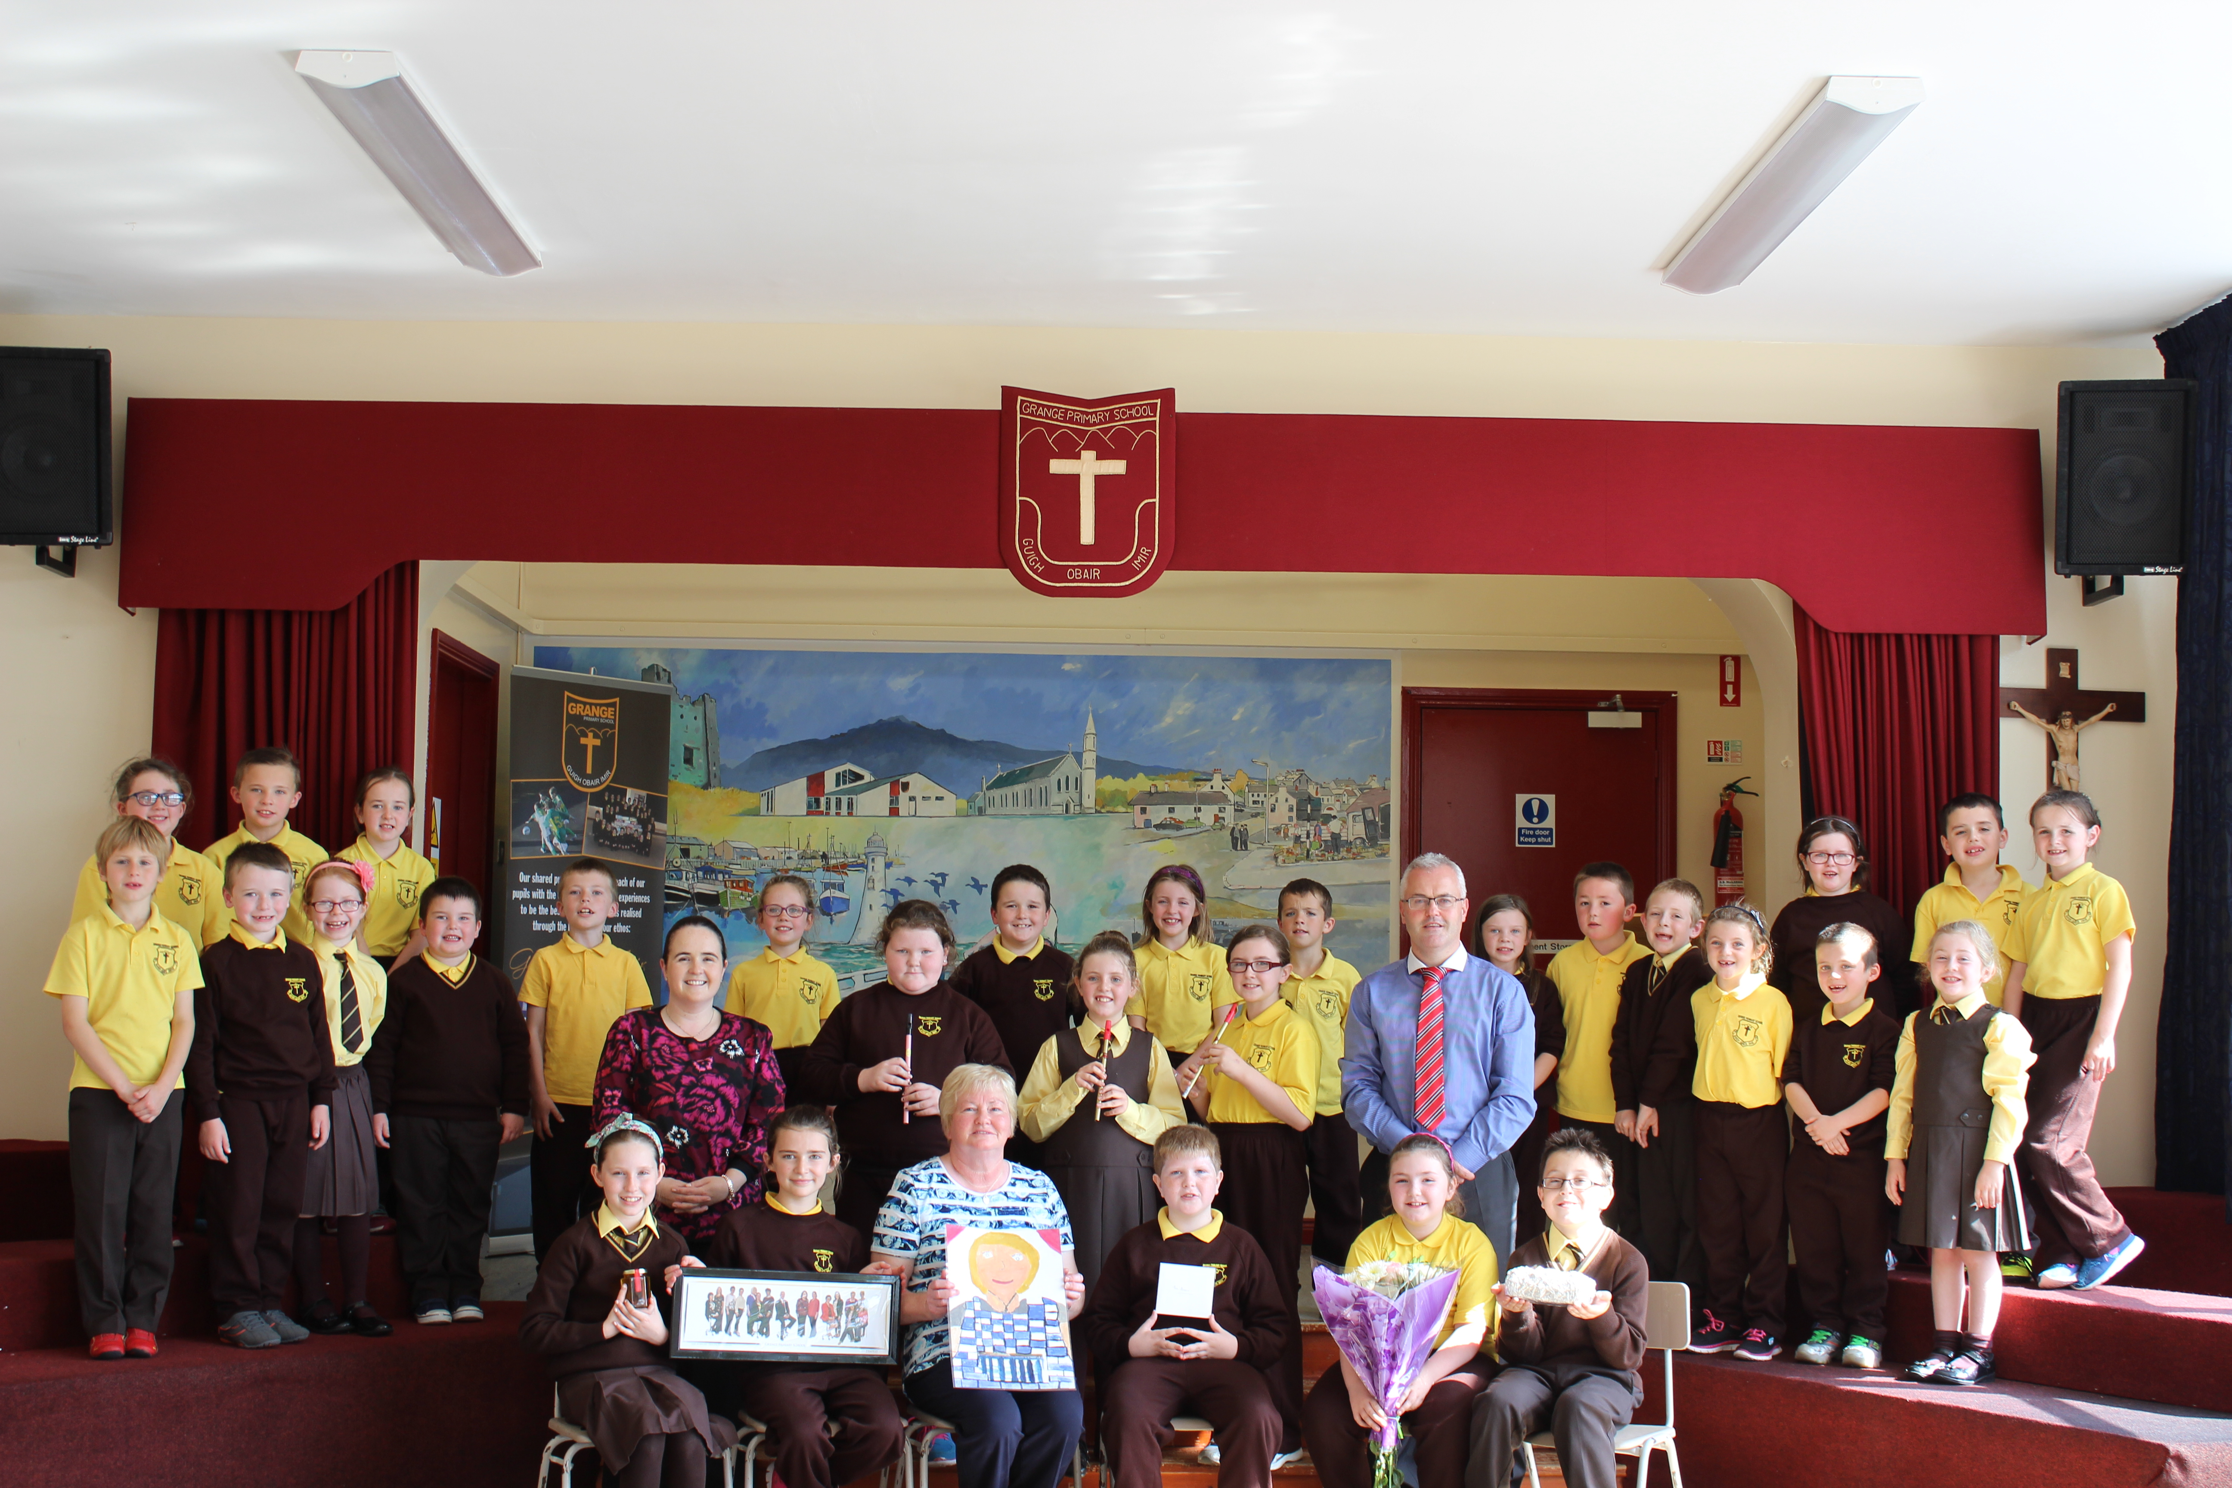
We say farewell to Mrs Hilary Morris

School tel: 4176 2033 email: info@grange.kilkeel.ni.sch.uk
Please access our website at:www.grangeprimaryschoolkilkeel.co.uk

after nearly 15 years of service in our school.

Hopefully, she enjoyed last Friday afternoon’s little ‘get together.’
Many thanks to the pupils who helped out on the day.
A presentation was made on behalf of pupils and parents.

We wish Mrs Morris a long and peaceful retirement.

Beginning Year Mass:
We celebrated our beginning year Mass of Thanksgiving on Monday last. We had a wonderful representation of parents, family members and parishioners. Well done to all who participated in the liturgy and a special well done to our Primary Ones on their first attendance at mass with our school community.
Class Assembly:
Our first assembly of this academic year will be presented by the pupils from the P6/7 class on Monday 28th September at our 10.00am assembly. Parents and family members are warmly invited to attend.
Grange Primary School Board of Governors:
Following the most recent election of a new parent representative, we can confirm to parents that the membership of our present Board is as follows:
Mr. Sean Rogers (Chairperson & Safeguarding Representative / SELB Representative)
Fr. Sean Dillon (Trustee)
Mrs. Caitriona Stack (Trustee & Safeguarding Representative)
Mr. Oliver Sloan (Trustee)
Mr. Michael O’ Rourke (Trustee)
Mrs. Anne Mullan (SELB Representative)
Mr. Gerard Mc Givern (DE Representative)
Mrs. Linda Mc Conville (Parent Representative)
Mrs. Gail Digney (Teacher Representative)
Mr. Sean Mc Kinley (Principal)
If any parent wishes to make a contribution to any aspect of school life and feels the matter should be addressed by the Governors, they should put the matter in writing and forward it to school, for the attention of the secretary to Grange Primary School Board of Governors.
Primary One:
Keep a look out in next week’s edition of ‘The Outlook’ for a school supplement featuring photos of Primary 1 pupils from a number of local schools. The actual photo is available for parents to purchase from school at a cost of £4.00
Flu Vaccination Programme:
All returned forms were collected by our school nursing team last Tuesday. Any remaining forms should re returned immediately and we will have them forwarded.The vaccination programme will occur in our school on Wednesday 25th November.
Altar Servers:
A new rota for altar servers will be completed and commence shortly.
Head Boy/Girl:
We have received letters of application from the Primary 7 boys and girls and further to nominations, elections took place today in school. We hope to announce details of the new Head Boy and Head Girl incumbents on Monday coming.
Friends of Grange Meeting:
The Friends of Grange Parents’ group are working hard to make final preparations for our BIG fundraising initiative this year, our Jim Devine dance in The Carrickdale on Friday 02 October. We thank all those parents who have helped by buying tickets to go along on the night and tickets for the great raffle also. Please return tickets both sold and unsold as soon as possible.

Trip to Medjugorje :
A trip to Medjugorje is currently being organised for June 2016. If anyone is interested or would like further further details, please contact :
Mrs. Deborah O'Hare 417 64415 or 07894412276'
Friday 25th September:
Next Friday 25th, the United Nations will announce its ‘Global Goals for Sustainable Development.’ These worldwide goals aim to make our planet ‘fair, healthy and sustainable’ by the year 2030. Our P6/7 assembly will begin a week of information on this initiative.
Saturday 26th September is annual European Day of Languages.
Transport:
Anyone interested in travelling on a bus to the Carrickdale on 02 October, should make contact with Mrs. Murnion in school directly as soon as possible.
Come Dancing – Learn to Jive:
In the lead up to our Jim Devine dance, last Monday night saw the second of a series of jiving lessons taking place in Grange school hall for a 4 week period from 8.00-10.00pm (Cost £8.00 per lesson). We welcomed some new faces and some ‘old hands’. Anyone still interested, come along next Monday at 8.00pm.
Musical Tuition:
Tin whistle tuition begins today with Mr. Danny Mc Greevy. We look forward to our new whistlers making as much progress as our experienced group have done during their time.
After School Clubs:
After school clubs commence next Wednesday, 23 September for a 5 week block. Specific classes / year groups should have received appropriate Permission Notes to complete.
Comhaltas Registration:
A leaflet went home today with details relating to registration on Tuesday 22nd September from 7-8pm in the Gaelscoil, Kilkeel.
Cool Kids:
Our P2/3 pupils begin a series of lessons next week, delivered by one of our school’s outside educational bodies, the ACE Team. We hope they enjoy it.
Computer Based Assessments (P4-7):
In a couple of weeks, pupils from P4-7 will complete computer based assessments in literacy (NILA) and numeracy (NINA). A letter was sent home this week informing parents of the nature of these assessments and how pupils can access a ‘Practice area’ at home in preparation.
Makaton Taster Session:
A taster session of this communication programme will occur on Wednesday 7th October (7-9pm) at Mourne Stimulus Day Centre. Contact Bronagh on 07704945621 for further details.
Dates for the Diary:
Friday 25 September – Registration deadline for 2015 GL Assessment Transfer Test;
Friday 25 September – European Day of Languages in school;
Monday 28 September – Primary 6/7 class assembly;
Monday 28 September – Primary 1 pupils remain until 2.00pm;
Monday 05 October – Deposit deadline for P4-7 pantomime;

